TCT Prototype REV002 WIRING Manual Control Control/Drive/Code Hardware

===================================================================

BEGIN SESSION I

[IBT-2 Web Page](http://www.hessmer.org/blog/2013/12/28/ibt-2-h-bridge-with-arduino/)

IBT -2 43 Amp Drive

[Arduino Uno](https://www.arduino.cc/en/Main/ArduinoBoardUno)

[IBT-2 Web Page](http://www.hessmer.org/blog/2013/12/28/ibt-2-h-bridge-with-arduino/)

[AnalogWrite - PWM](https://www.arduino.cc/en/Reference/analogWrite)

[Voltage Divider Tutorial](https://www.allaboutcircuits.com/textbook/experiments/chpt-3/potentiometer-voltage-divider/)

[Wireless Remote Control](https://docs.google.com/document/d/1AaQmwKiLiiIFLeP8Kk19p4IfnDybd08enQUj-TCrXoc/edit?usp=sharing)

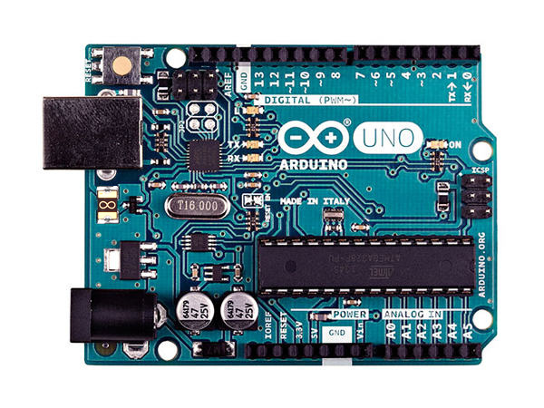

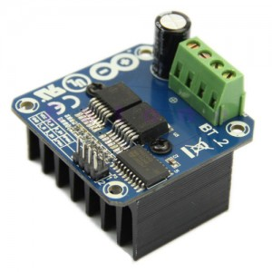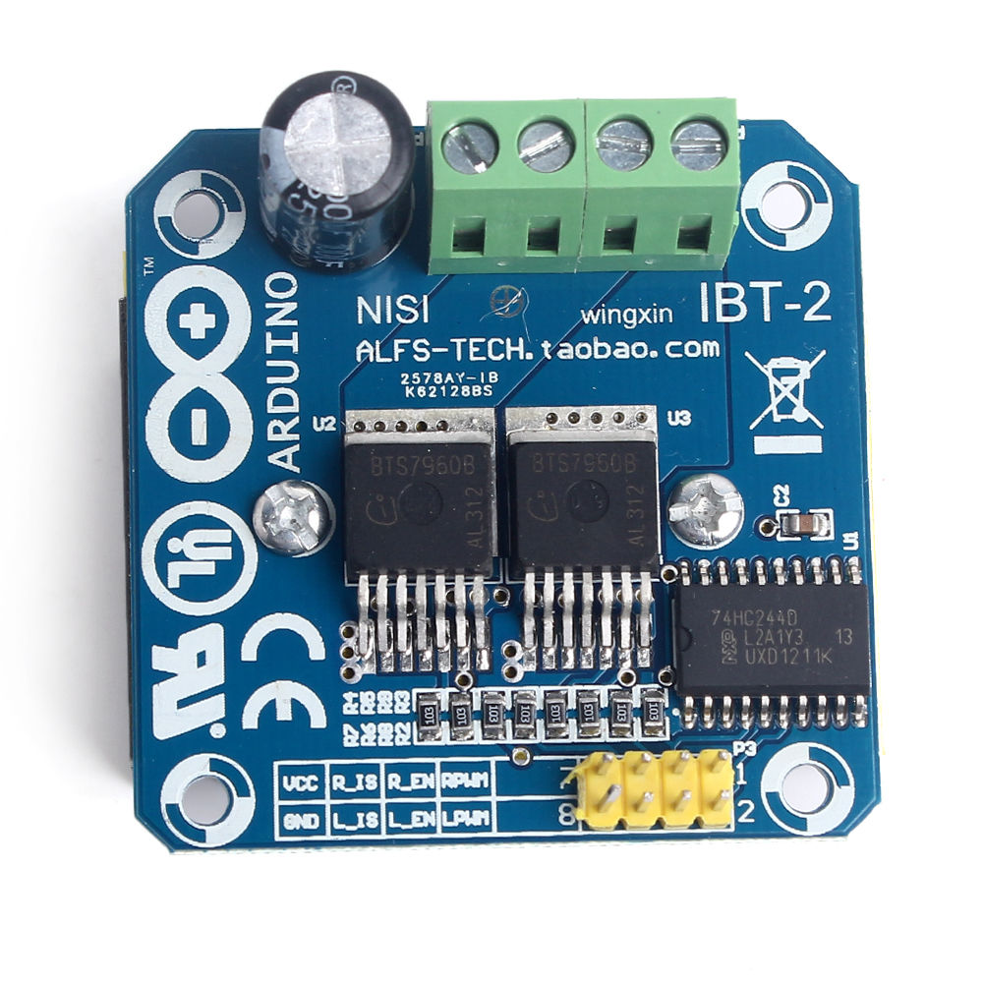

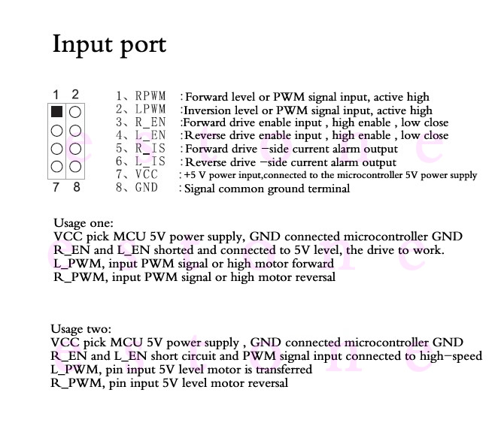

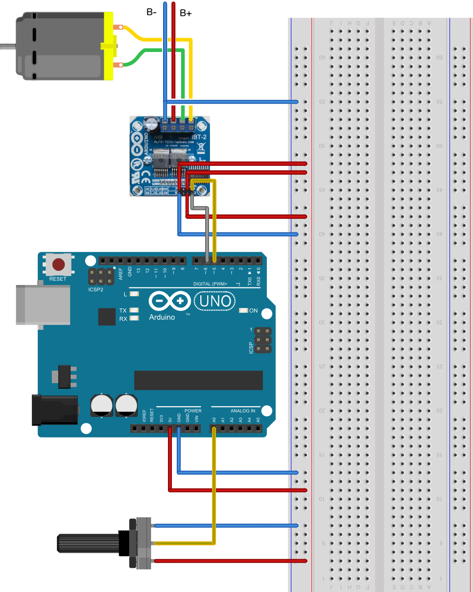

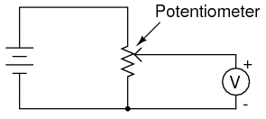

Code for 43 Amp PWM drive.

/*

IBT-2 Motor Control Board driven by Arduino.

Speed and direction controlled by a potentiometer attached to analog input 0.

One side pin of the potentiometer (either one) to ground; the other side pin to +5V

Connection to the IBT-2 board:

IBT-2 pin 1 (RPWM) to Arduino pin 5(PWM)

IBT-2 pin 2 (LPWM) to Arduino pin 6(PWM)

IBT-2 pins 3 (R_EN), 4 (L_EN), 7 (VCC) to Arduino 5V pin

IBT-2 pin 8 (GND) to Arduino GND

IBT-2 pins 5 (R_IS) and 6 (L_IS) not connected

*/

int SENSOR_PIN = 0; // center pin of the potentiometer

int RPWM_Output = 5; // Arduino PWM output pin 5; connect to IBT-2 pin 1 (RPWM)

int LPWM_Output = 6; // Arduino PWM output pin 6; connect to IBT-2 pin 2 (LPWM)

void setup()

{

pinMode(RPWM_Output, OUTPUT); // Pin 5 to Right Output

pinMode(LPWM_Output, OUTPUT); // Pin 6 to Left Output

}

void loop()

{

int sensorValue = analogRead(SENSOR_PIN); // Get Analog Input Value (A0)

// sensor value is in the range 0 to 1023 // Normal range of analog input

// the lower half of it we use for reverse rotation; the upper half for forward rotation (middle value is stop).

if (sensorValue < 512)

{

// reverse rotation 511=zero speed

int reversePWM = -(sensorValue - 511) / 2;

analogWrite(LPWM_Output, 0);

analogWrite(RPWM_Output, reversePWM);

}

else

{

// forward rotation

int forwardPWM = (sensorValue - 512) / 2;

analogWrite(LPWM_Output, forwardPWM);

analogWrite(RPWM_Output, 0);

}

}

## analogWrite()

#### Description

Writes an analog value ([PWM wave](https://www.arduino.cc/en/Tutorial/PWM)) to a pin. Can be used to light a LED at varying brightnesses or drive a motor at various speeds. After a call to analogWrite(), the pin will generate a steady square wave of the specified duty cycle until the next call to analogWrite() (or a call to digitalRead() or digitalWrite() on the same pin). The frequency of the PWM signal on most pins is approximately 490 Hz. On the Uno and similar boards, pins 5 and 6 have a frequency of approximately 980 Hz. Pins 3 and 11 on the Leonardo also run at 980 Hz.

===================================================================

BEGIN SESSION II

Objective: Control the Zip Scooter motor using a Key Fob Remote. Two buttons would allow the user to propel the TCT in the forward or reverse direction. The speed would be controlled by the program (fixed at this point). The direction would be set using the Key Fob Remote, buttons A and B.

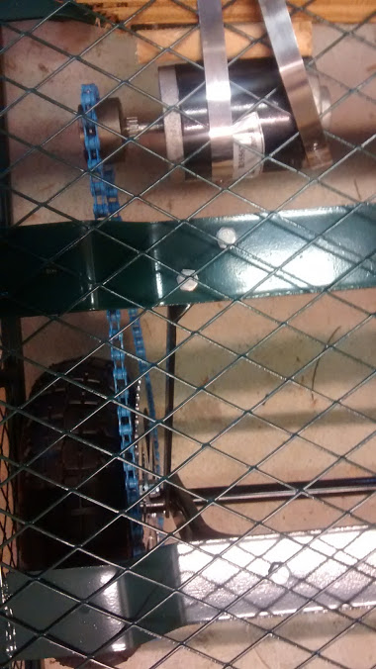

FINAL VERSION TESTED - CHANGES

**In the documentation from session one we used a common drive/uno voltage (5V)**

**In order to use a 12 volt motor we had to adust the system.**

1. **Split the supply voltage for the UNO to a different supply.**
2. **Share the ground between the UNO and the Drive**
3. **Wired 2 inputs to the Wireless Remote Command Module N.O. contacts**
4. **Provided positive power to each N.O. contact (using buttons A and B)**

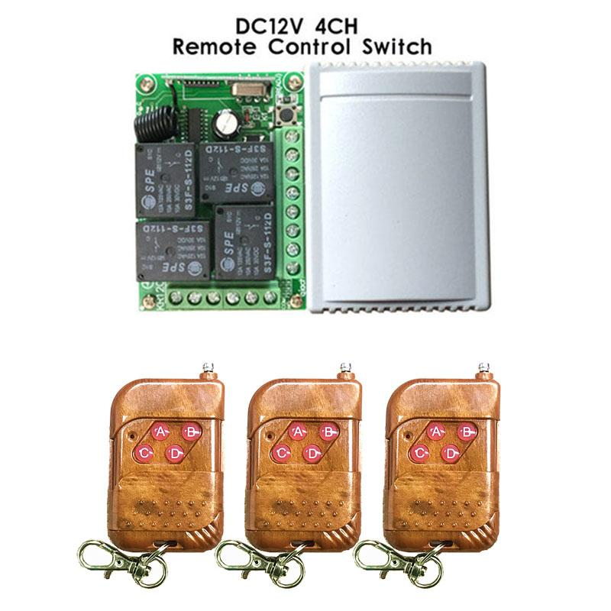

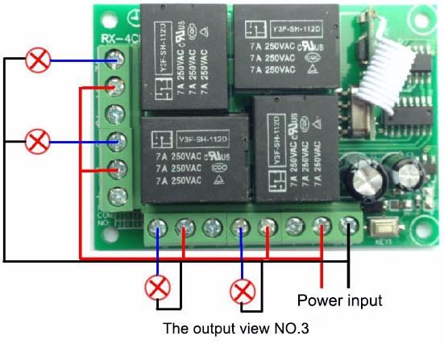

Wireless Remote Key Fob

[A. Wireless Remote Key Fob](https://docs.google.com/document/d/1AaQmwKiLiiIFLeP8Kk19p4IfnDybd08enQUj-TCrXoc/edit?usp=sharing)

1. Provided ground to each of the N.C. contacts.
2. At this point I applied power to the Zip motor (not on ground - no load)

This worked quite well in both directions.

1. Then I put the wheel used for propulsion in contact with the ground.
2. I was barely able to notice an attempt of movement. (the torque appeared to be very low).
3. What should I suspect the problem is and how should I debug the problem.

* 5s
* James McCrary's profile photo
* [James McCrary](https://plus.google.com/u/0/110298790876801135283)
* I am suspecting I need to increase the gear ration for more torque. I am current at 16T and 52T. I am looking at 7T and 80T found on 49 and 49 cc dirt bikes (25H chain). Ordered Today.
* 1s
* James McCrary's profile photo
* [James McCrary](https://plus.google.com/u/0/110298790876801135283)
* Houston, we have liftoff. I was able to accelerate the TCT. The bad news: It won''t go up hill. With the addition of a battery and airing up a flat tire the TCT did move. I am hoping the new gearing will get her up hill. 4.33 vs 12.857

TCT Wiring Diagrams Rev 2

Key Fob Wiring

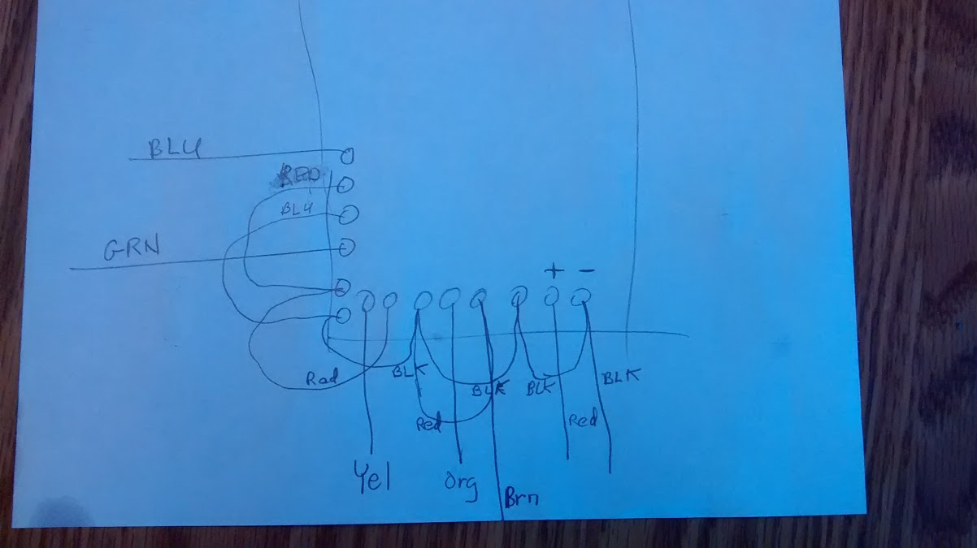

Latest Propulsion Control System Wiring 8/24/2012

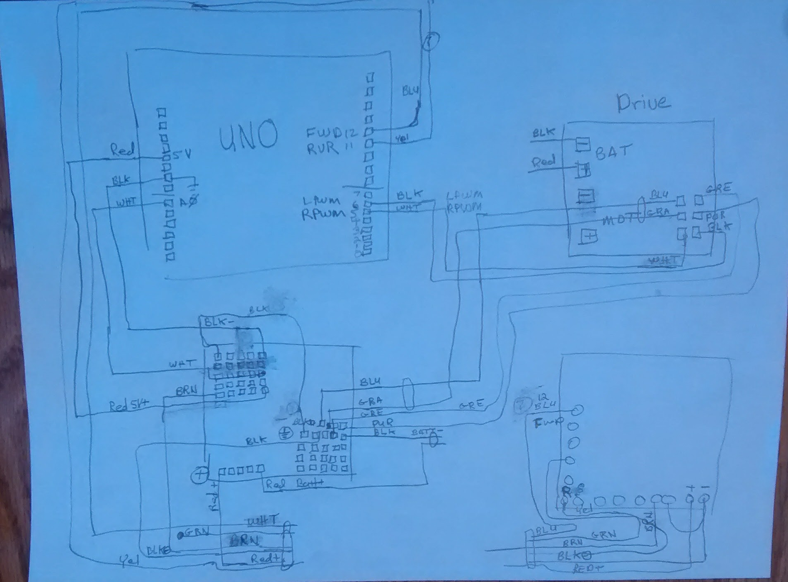

[Video of TCT in Motion with 24VDC System](https://photos.google.com/photo/AF1QipNQcm_T1wFc6Xpch7mt__IoYGL8gZuy0QlNEAYT)

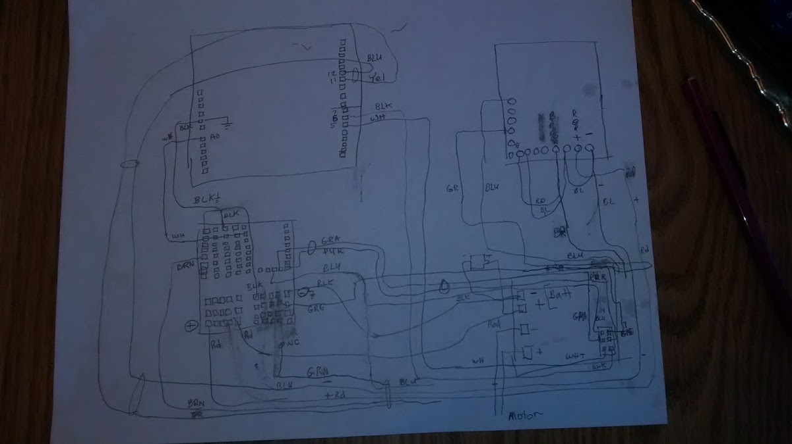

/*

IBT-2 Motor Control Board driven by Arduino.

20170331 Potientiometer taken out of code.

20170419 Wired Remote contacts (8) to inputs 11/12.

Had to add (-) connected to nc to prevent input floating.

Connection to the IBT-2 board:

IBT-2 pin 1 (RPWM) to Arduino pin 5(PWM)

IBT-2 pin 2 (LPWM) to Arduino pin 6(PWM)

IBT-2 pins 3 (R_EN), 4 (L_EN), 7 (VCC) to Arduino 5V pin

IBT-2 pin 8 (GND) to Arduino GND

IBT-2 pins 5 (R_IS) and 6 (L_IS) not connected

*/

// int SENSOR_PIN = 0; // center pin of the potentiometer

int zeroSpeed = 0; //

int maxReverse = 123; //

int maxForward = 123; //

int RPWM_Output = 5; // Arduino PWM output pin 5; connect to IBT-2 pin 1 (RPWM)

int LPWM_Output = 6; // Arduino PWM output pin 6; connect to IBT-2 pin 2 (LPWM)

int reverse_Input = 11; // Arduino Reverse Signal input (input from remote)

int forward_Input = 12; // Arduino Forward Signal input (input from remote)

void setup()

{

//Initialize serial and wait for port to open:

Serial.begin(9600);

pinMode(RPWM_Output, OUTPUT);

pinMode(LPWM_Output, OUTPUT);

pinMode(forward_Input, INPUT);

pinMode(reverse_Input, INPUT);

}

void loop()

{

int driveSetpoint;

driveSetpoint = zeroSpeed;

if (digitalRead(reverse_Input) == HIGH) // REVERSE rotation

{

driveSetpoint = maxReverse;

Serial.println("---> Reverse Selected");

int reversePWM = driveSetpoint;

analogWrite(LPWM_Output, 0);

analogWrite(RPWM_Output, reversePWM);

Serial.print("---> Reverse OUTPUT Selected: ");

Serial.println(reversePWM);

}

if (digitalRead(forward_Input) == HIGH) // FORWARD rotation

{

driveSetpoint = maxForward;

Serial.println("---> Forward Selected");

int forwardPWM = driveSetpoint;

analogWrite(LPWM_Output, forwardPWM);

analogWrite(RPWM_Output, 0);

Serial.print("---> Forward OUTPUT Selected: ");

Serial.println(forwardPWM);

}

if (digitalRead(forward_Input) == LOW && (digitalRead(reverse_Input) == LOW)) // FORWARD rotation

{

driveSetpoint = 0;

Serial.println("---> STOP SELECTED ");

analogWrite(LPWM_Output, 0);

analogWrite(RPWM_Output, 0);

Serial.print("---> STOP OUTPUT Selected: ");

// Serial.println(forwardPWM);

}

Serial.println("------------------------------------------------------------------------------");

delay(800);

}

/*

IBT-2 Motor Control Board driven by Arduino.

20170331 Potientiometer taken out of code.

20170419 Wired Remote contacts (8) to inputs 11/12.

Had to add (-) connected to nc to prevent input floating.

Connection to the IBT-2 board:

IBT-2 pin 1 (RPWM) to Arduino pin 5(PWM)

IBT-2 pin 2 (LPWM) to Arduino pin 6(PWM)

IBT-2 pins 3 (R_EN), 4 (L_EN), 7 (VCC) to Arduino 5V pin

IBT-2 pin 8 (GND) to Arduino GND

IBT-2 pins 5 (R_IS) and 6 (L_IS) not connected

*/

// int SENSOR_PIN = 0; // center pin of the potentiometer

int zeroSpeed = 0; //

int maxReverse = 123; //

int maxForward = 123; //

int RPWM_Output = 5; // Arduino PWM output pin 5; connect to IBT-2 pin 1 (RPWM)

int LPWM_Output = 6; // Arduino PWM output pin 6; connect to IBT-2 pin 2 (LPWM)

int reverse_Input = 11; // Arduino Reverse Signal input (input from remote)

int forward_Input = 12; // Arduino Forward Signal input (input from remote)

void setup()

{

//Initialize serial and wait for port to open:

Serial.begin(9600);

pinMode(RPWM_Output, OUTPUT);

pinMode(LPWM_Output, OUTPUT);

pinMode(forward_Input, INPUT);

pinMode(reverse_Input, INPUT);

}

void loop()

{

int driveSetpoint;

driveSetpoint = zeroSpeed;

if (digitalRead(reverse_Input) == HIGH) // REVERSE rotation

{

driveSetpoint = maxReverse;

Serial.println("---> Reverse Selected");

int reversePWM = driveSetpoint;

analogWrite(LPWM_Output, 0);

analogWrite(RPWM_Output, reversePWM);

Serial.print("---> Reverse OUTPUT Selected: ");

Serial.println(reversePWM);

}

if (digitalRead(forward_Input) == HIGH) // FORWARD rotation

{

driveSetpoint = maxForward;

Serial.println("---> Forward Selected");

int forwardPWM = driveSetpoint;

analogWrite(LPWM_Output, forwardPWM);

analogWrite(RPWM_Output, 0);

Serial.print("---> Forward OUTPUT Selected: ");

Serial.println(forwardPWM);

}

if (digitalRead(forward_Input) == LOW && (digitalRead(reverse_Input) == LOW)) // FORWARD rotation

{

driveSetpoint = 0;

Serial.println("---> STOP SELECTED ");

analogWrite(LPWM_Output, 0);

analogWrite(RPWM_Output, 0);

Serial.print("---> STOP OUTPUT Selected: ");

// Serial.println(forwardPWM);

}

Serial.println("------------------------------------------------------------------------------");

delay(800);

}

Alternate Drive Mechanism

